Elevator Speech
(30-Second Commercial)

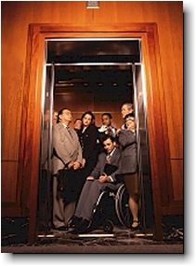
A-C-E-S
First, introduce yourself – name, grade, school.
ACADEMICS: List education and credentials – advanced courses, special classes, Practicum in Business Management I.
CLUBS AND ACTIVITIES: Discuss your extra-curricular activities – athletics, clubs (in and out of school), awards, competition, volunteer hours, Most recent accomplishment.
EXPERIENCE: Areas of experience you have – where have you worked in the past two years, if you haven’t worked, discuss volunteer experience (if you mention volunteer exp, during clubs and activities, do not mention it again here).
SKILLS: Look for your strengths – what are you good at, skills, languages, etc. Include examples – I am very punctual, I like to arrive 10-15 minutes early to appointments.
Present goal – need to include mentioning that you would like to work for the employer and that you would be an asset to the organization, or you would be an excellent employee, or a great part of the team, etc.
Following the format above, type your response below. Check spelling and grammar.

